SC-300 Notes (IAM) Identity & Access Admin Associate
MSFT Entra ID:
- Define common identity terms and explain how they're used in the Microsoft Cloud.
- Explore the common management tools and needs of an identity solution.
- Review the goal of Zero Trust and how it applies in the Microsoft Cloud.
- Explore the available identity services in the Microsoft Cloud.

Zero Trust principles
Verify Explicitly | Use least privilege access | Assume breach
Always validate all available data points including: | To help secure both data and productivity, limit user access using: | Minimize blast radius for breaches and prevent lateral movement by:
User identity and location | Just-in-time (JIT) | Segmenting access by network, user, devices, and app awareness
Device health | Just-enough-access (JEA) | Encrypting all sessions end to end
Service or workload context | Risk-based adaptive policies | Use analytics for threat detection, posture visibility and improving defenses
Data classification | Data protection against out of band vectors
Anomalies

Deploying Zero trust solutions:
There are 6 pillars:
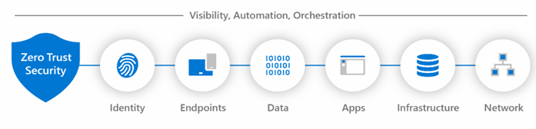
Verification is done with rich signal, stitching them together tells you what is most important, enabling you to respond fast with integrated remediation capabilities.
Control plane – routes network traffic around net arch, directing access to resources, user identity would be the place to check for access. Identity = CONTROL PLANE
IdP: - a sys that creates, manages, and stores digital identities
Most common components are
- A repository of user identities
- An authentication system
- Security protocols that defend against intrusion
- Someone we trust

Common identity protocols:
· OpenID provider (OIDC) - authen protocol based on (OAuth2 protocol which is used for authori). Uses message flows from OAuth2 to provide identity services via a RESTful HTTP API.
· SAML identity provider – open standard for exchanging authentication and authorization data between an identity/service provider.

Common identity admin tasks:
· Identity proliferation – deals with the storage of identity objects within the environment
· Provision & Deprovision – creation and removal of identities (deletion, disablement of security principle)
· Identity updates – how identity is updated, and move from a manual effort to an automated one
· Synchronization – ensures identity systems are up to date with latest identity info.
· Password mgmt. – where/how passwords are set through the infrastructure. Help desk resets pws usually.
· Group mgmt. – how orgs manage groups (like AD or LDAP) in environment, Most common but expensive.
· User Interface – how user requests/make updates to their identity, usually through contacting Service desk
· Change Control – focus on how changes flow through the env. whether done by service desk, there can be automation w/wo workflow, which drives the change process
· App Entitlement mgmt. – how identities are granted to access to apps.
o Focuses on coarse-grained app entitlements – which grants/denies access based on a single factor (often a user’s role or group membership) – Implemented through RBAC
o Fine-grained app entitlements – more granular, focuses more on control over access considering multiple attributes & conditions – Implemented through ABAC (attribute) or PBAC (policy-based)
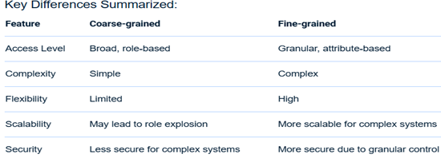
Microsoft Graph:
· MSFT Graph API – use REST APIs or SDKs to access the endpoint https://graph.microsoft.com for insights into M365 Windows 10 and Enterprise Mobility + Security
· MSFT Graph Connectors – delivers data external to the M cloud into Graph services and apps to enhance M365 experiences
· MSFT Graph Data Connect -provide a set of tools to streamline scalable delivery of Graph data to popular Azure data stores
All 3 together power the MSFT cloud services platform.

B2C is a separate service from Entra ID, allow businesses to build customer facing apps & then anyone can sign up into those apps w/o restrictions on user acct.
Claims-based identity
- Claim - a value pair of data within a security token. There are multiple claims transferred within the token from the claim that defines the type of the token to the encryption method. Example:
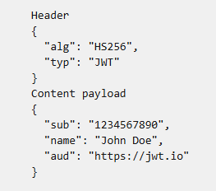
- Assertion - a package of data, usually in the form of a token that shares the identity and security information about a user or account across security domains.
- Attribute - a value pair of data within a token.
- Augmentation - the process of adding other claims to the user token to provide extra detail about the user. This could include data from human resource (HR) systems, from an application like SharePoint, or other systems.

Auditing in identity
Event logs
Activity logs
Sign-in logs
Provisioning logs
Audit logs
Azure Monitor
MS Sentinel

Identity Lifecycle Management
- Join - when an individual comes into scope of needing access, an identity is needed by those applications, so a new digital identity might need to be created if one isn't already available.
- Move - when an individual moves between boundaries, extra access authorization is required to be added or removed to their digital identity.
- Leave - when an individual leaves the scope of needing access, access might need to be removed, and the identity is no longer be required by applications other than for audit or forensics purposes.

Monitoring tools:
- Azure Monitor
- Application Insights
- Azure Service Health
- Azure Resource Health
- Azure Resource Manager
- Azure Policy
Administrative Units
You can have users in the following roles to manage your administrative unit:
- Authentication administrator
- Helpdesk administrator
- License administrator
- Password administrator
- User administrator
Defining Roles
Each task should be evaluated for frequency, importance, and difficulty
Entra Security Defaults:
Requiring all users to register for multifactor authentication (MFA).
- Requiring administrators to perform multifactor authentication.
- Blocking legacy authentication protocols.
- Requiring users to perform multifactor authentication when necessary.
- Protecting privileged activities like access to the Azure portal.
Tenant ID settings
- Entra ID > Overview tab > Properties
- Is where Privacy Statement URL should go
Dynamic Groups
The final type of group is a dynamic group, which the name implies, the membership is generated by a formula each time the group is used. A dynamic group includes any recipient in Active Directory with attribute values that match its filter.
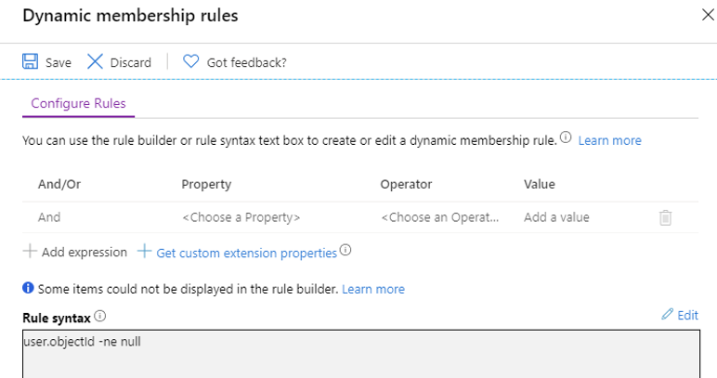
Consist of all valid members of the Entra ID
Hybrid entra joined devices
Typically, organizations with an on-premises footprint rely on imaging methods to configure devices, and they often use Configuration Manager or group policy (GP) to manage them
Usage Location Isn’t Allowed
When Microsoft Entra ID assigns group licenses, any users without a specified usage location inherit the location of the directory. We recommend that administrators set the correct usage location values on users before using group-based licensing to comply with local laws and regulations.
Dynamic groups
- Automation – No manual member updates.
- Consistency – Always up-to-date membership.
- Licensing & Access Control – Often paired with group-based licensing, Intune device policies, or application access assignments.
- Security – Auto-remove access when someone’s role or department changes.
Cloud Authentication
Password hash synch (PHS)- use same usrn & pw to login into on-prem AD to Entra Connect
- Effortless to setup
- SSO deployed
- Suggest to deploy a 2nd Entra connect server in staging mode on standby configuration
- Run new synch when updates are done to the on-prem AD - doesn’t enforce changes
Pass through AuthN (PTA) - provides pw validation by using sw agent running on on-prem server, the server validates directly ensuring it doesn’t happen in the clod
- Need at least 3 lightweight agents installed on-prem servers, needing access to your AD DS and your AD domain controllers
- SSO deployed
- Suggests deploying 2 add’l agents for high availability,1 for mainten./failure, have another
- Enforces your on-prem AD state/policies at time of login
- Can use PHS if on-prem AD servers fail
Federated Authentication
Active Directory Federation Service (AD FS) - is when Entra ID uses a trusted external party to validate authentication on-prem
- Org usually keep if invested on-prem already, company secures, more complex 2 operate
- Can be configured to auto sign in users and devices, all based on company requirements
- Needed when Entra doesn’t support a native authN requirement
- Requires smartcards or certificates
- Requires a load-balanced array of servers (farm) ensures availability of authN request
Why Organizations Use Federated Auth with AD FS
- Password Stays On-Prem: Cloud service never stores or validates the password — only AD FS talks to AD.
- Custom Policies: You can enforce conditional access rules in AD FS before issuing tokens.
- Legacy Support: AD FS can bridge to apps that use WS-Fed or SAML 1.1 that Entra ID might not natively support.
- True SSO: On corporate devices, users can log in without entering credentials again.

How to fix AttributeValueMustBeUnique error (errors during export to Entra)
- Identify the duplicated proxyAddresses, userPrincipalName or other attribute value that's causing the error. Also identify which two (or more) objects are involved in the conflict. The report generated by Microsoft Entra Connect Health for sync can help you identify the two objects.
- Identify which object should continue to have the duplicated value and which object shouldn't.
- Remove the duplicated value from the object that shouldn't have that value. You should make the change in the directory where the object is sourced from. In some cases, you need to delete one of the objects in conflict.
- If you made the change in the on premises AD, let Microsoft Entra Connect sync the change for the error to get fixed.
Admin role conflict
Description: An Existing Admin Role Conflict will occur on a user object during synchronization when that user object has:

- administrative permissions and
- the same UserPrincipalName as an existing Microsoft Entra object
How to fix
To resolve this issue do the following:
- Remove the Microsoft Entra account (owner) from all admin roles.
- Hard Delete the Quarantined object in the cloud.
- The next sync cycle will take care of soft-matching the on-premises user to the cloud account (since the cloud user is now no longer a global GA).
- Restore the role memberships for the owner.
MFA
- Should always support more than 1 method (mobile app verification, FIDO2, OATH token, etc)
- Use Entra ID Protection to register the employees/clients choice of MFA
Troubleshooting conditional access policies
- Get an interrupted sign-in- check monitoring and insights and filter to find the incident
- Click incident then go to CA tab, will show the exact policy that created the interruption
- Selecting the ellipsis on the right of a fail event will bring up the policy details
CA Optimization Agent
An AI-driven assistant for Conditional Access (CA) policy management, this agent automatically scans your tenant to identify gaps—such as users or apps not covered by policies—and proposes intelligent optimizations based on Zero Trust best practices
- Gap detection: Spots users/apps missing protections like MFA, device compliance, or app protection enforcement.
- Policy consolidation: Identifies redundant or overlapping CA policies and suggests combining them.
- Legacy and risky sign-in control: Recommends blocking legacy authentication and device code flow, and—if on P2—addresses risky users and sign-ins.
- One-click suggestions: Actions like adding users to policies or creating new (report-only) policies can be applied with a single click.
- Reduces manual workload—no more spreadsheets or PowerShell scripts to track coverage.
- Enhances security posture—helps close gaps swiftly and align with best practices.
- Improves policy hygiene—through consolidation and phased deployment, minimizing deployment risks.
Identity Protection - monitoring their usage and sign-in patterns helps ensure a secure cloud solution
**Do a stage roll out with these policies, start with a small group and test before full rollout
- Implement User risk policy - detects the probability that a user account has been compromised by detecting risk events that are atypical of a user's behavior -set to HIGH
- Implement Sign-in risk policy - detects suspicious actions that come along with the sign-in. It's focused on the sign-in activity itself and analyzes the probability that the sign-in was performed by some other than the user. -set to MEDIUM
- Implement MFA registration policy
- Monitor, investigate, remediate elevated risky users
Process flow for Defender for Identity
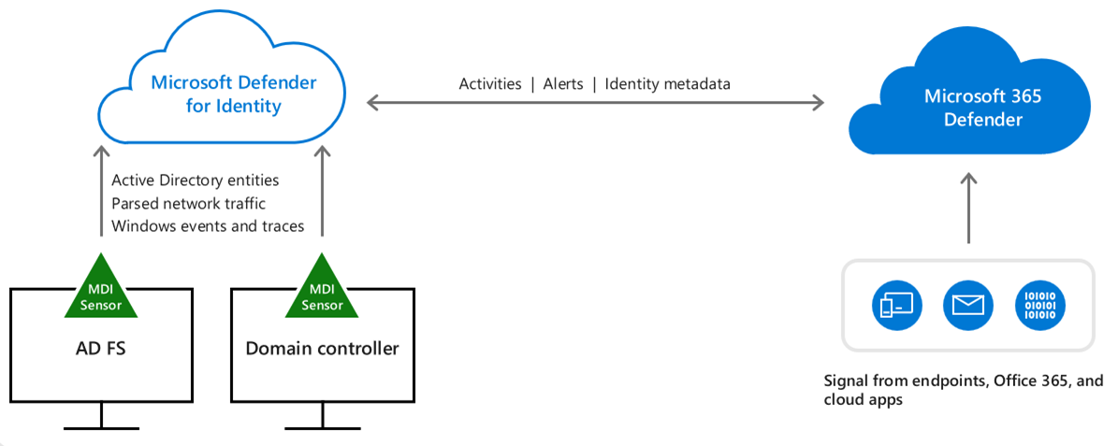
Global Secure Access (Entra Internet + Entra Private Access)
4 steps to deploy Entra Internet Access
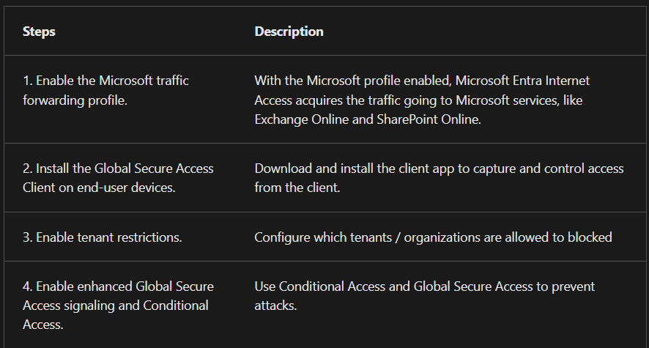
4 steps to deploy Entra Private Access
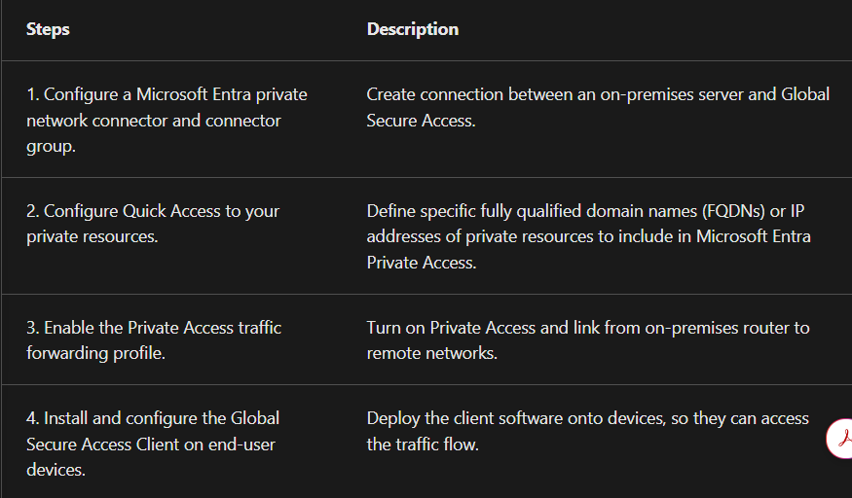
Integrating apps with older protocols
- Integrate apps using older protocols by using Application Proxy and/or Microsoft Entra Domain Services.
Configuring App Properties
- An app that uses SAML-based SSO will have fields such as User access URL whereas an app that uses OIDC-based SSO won't (within app properties).
- Apps added through Microsoft Entra ID - App registrations are by default OIDC-based apps
- Apps added through Microsoft Entra ID - Enterprise applications might use any SSO standard.
Comparisons of industry standard protocols
- OAuth vs. OpenID Connect: OAuth is used for authorization and OpenID Connect (OIDC) is used for authentication. OpenID Connect is built on top of OAuth 2.0, which means the terminology and flow are similar between the two. You can even authenticate a user using OpenID Connect and get authorization to access a protected resource that the user owns using OAuth 2.0 in one request.
- OAuth vs. SAML: OAuth is used for authorization and Security Assertion Markup Language (SAML) is used for authentication.
- OpenID Connect vs. SAML: Both OpenID Connect and SAML are used to authenticate a user and are used to enable single-sign-on. SAML authentication is commonly used with identity providers such as Active Directory Federation Services (ADFS) federated to Microsoft Entra ID and is therefore frequently used in enterprise applications. OpenID Connect is commonly used for apps that are purely in the cloud, such as mobile apps, web sites, and web APIs
SCIM
- System for Cross-domain Identity Management (SCIM) specification provides a common user schema to help users move into, out of, and around apps - created to address the different methods/schema apps used to specify user information

2 representations of applications in Microsoft Entra ID:
- application objects (the blueprint, copy, recipe) - define and describe the application to Microsoft Entra ID, enabling your identity provider to know how to issue tokens to the application based on its settings
- service principals (the instance, cake) - govern an application connecting to Microsoft Entra ID and can be considered.
Entitlement Management
When should I use access packages?
- Access packages don't replace other mechanisms for access assignment. They're most appropriate in situations such as when:
- Employees need time-limited access for a particular task. For example, you might use group-based licensing and a dynamic group to ensure all employees have an Exchange Online mailbox, and then use access packages for situations in which employees need additional access, such as to read departmental resources from another department.
- Access requires the approval of an employee's manager or other designated individuals.
- Departments wish to manage their own access policies for their resources without IT involvement.
- Two or more organizations are collaborating on a project, and as a result, multiple users from one organization will need to be brought in via Microsoft Entra B2B to access another organization's resources.the instance of the application in your directory.
Catalog - is a container of resources and access packages.You create a catalog when you want to group related resources and access packages.
Access Review Policy Matrix

Group / Access Type | Frequency | Reviewer | Duration | Upon Completion Setting | Notes / Best Practice
Privileged Roles & Sensitive Groups (Global Admins, Security Admins, Finance, HR, Compliance) | Quarterly (every 3 months) | Group owner + Security/Compliance officer | 14–30 days | Remove access by default if not reviewed | Strict governance; ensures least privilege; Microsoft recommended default
Business-Critical Apps & Departmental Groups (Salesforce, SharePoint, Teams, Ops apps) | Semi-annual (every 6 months) | Group owner or department manager | 30 days | Keep access by default if not reviewed | Prevents accidental workflow disruption; non-reviewed accounts flagged for follow-up
General Access / Broad Groups (All Employees, newsletters, collaboration) | Annual (every 12 months) | Group owner | 30 days | Keep access by default (system recommendation if enabled: remove if inactive 90+ days) | Light-touch governance; focus is on hygiene rather than strict removal
Dynamic Groups (automated by attributes) | Not applicable | Not applicable | Not applicable | Managed by automation | No manual review needed; relies on HR/attribute accuracy
Managed Identity SAMI v. UAMI:
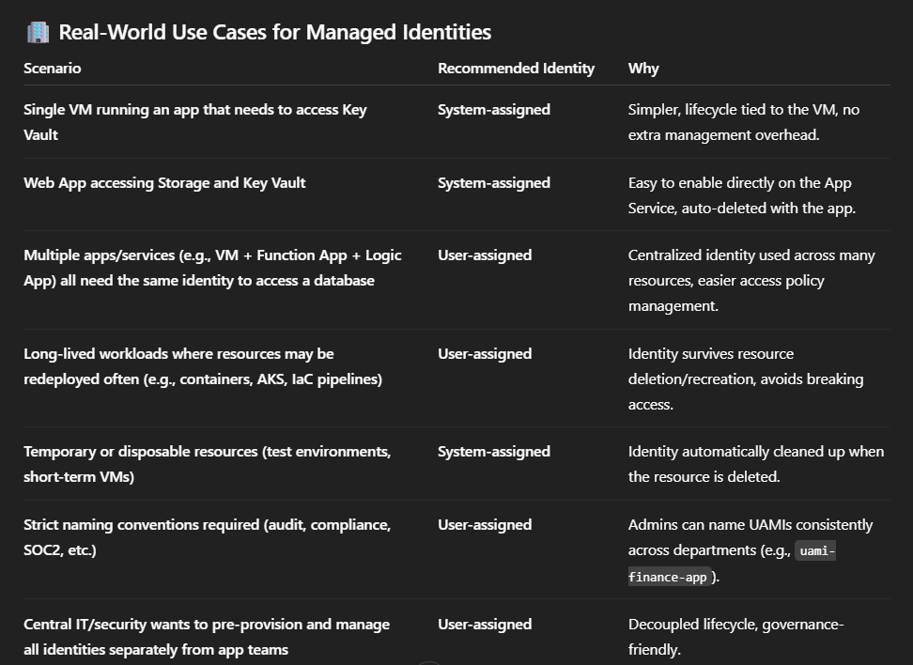

Only 3 Azure roles can approve admin consent requests:
- Global Admin
- Cloud App Admin
- App Admin
You use a Session Policy in Microsoft Defender for Cloud Apps (MDCA) when you want to control real-time user actions in SaaS apps — such as viewing, downloading, uploading, cutting, copying, or printing files during an active session.
To manage policies, including access and session policies, you must have the Global admin, Security admin, or Cloud App Security admin role.”
- If the question says “minimize administrative effort” → Managed Identity
- If the question says “non-Azure service or external system” → Service Principal
- If the question says “reuse one identity across several resources” → User-assigned Managed Identity
- If the question says “each resource should have its own” → System-assigned Managed Identity
ABAC in Azure is supported only for Azure Storage (specifically Blob and Queue data operations)
Only member users (like User1) can be made eligible for Azure AD roles in PIM; guest users and managed identities cannot.
User Admins can reset passwords only for users who are non-admins or have lower privilege.
A user can accept Terms of Use on any device, even if the device is not registered. Terms of Use enforcement occurs at sign-in, not based on device registration.

Managed identities can be added ONLY to:
- Azure AD security groups
- Cloud-based groups
- Not Microsoft 365 groups
- Not dynamic groups
- Not Windows Server AD–synced groups
- Not distribution lists
Azure AD cloud users can be added to:
- Any assignable cloud group (security or M365)
- Not to dynamic membership groups
- Not to on-premises sync groups

Configuring/managing a MS Entra tenant (labs)
Configuring external B2B collab settings in Entra ID (Least privilege access)

Enabled guest self-service sign up as well
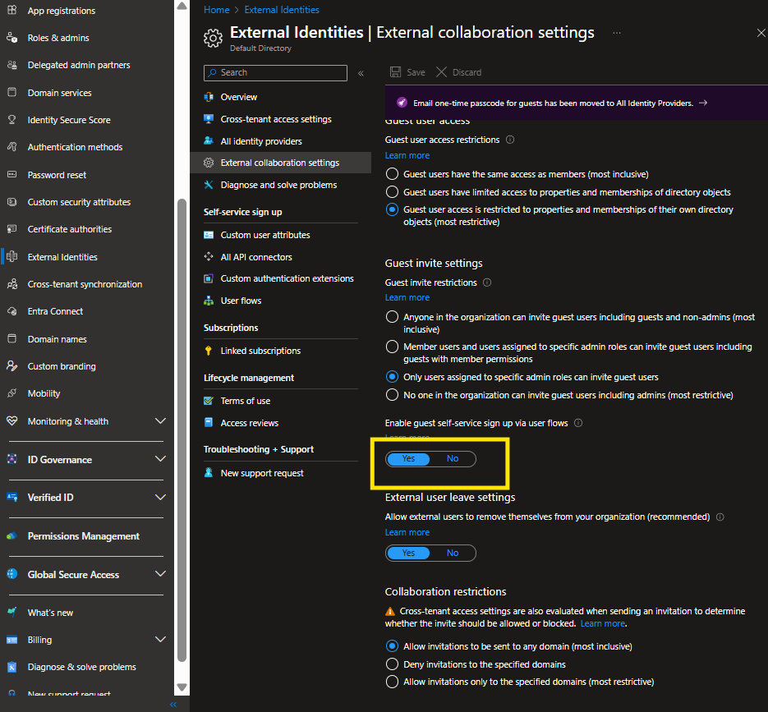
Created a new user flow for the self service sign up
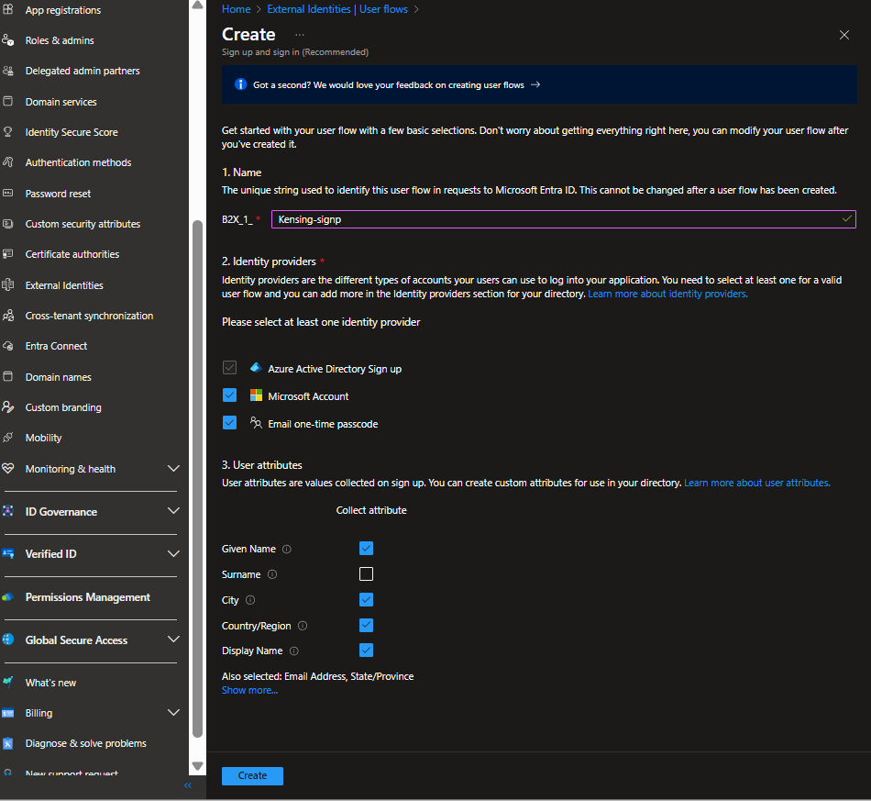
Bulk invited 30 guest users using .csv template
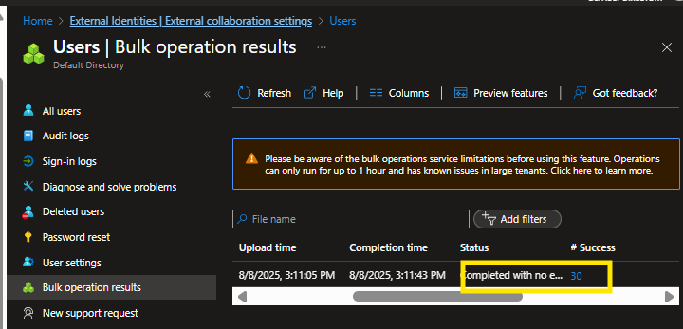
Configured Google IdP via Drive API with OAuth client
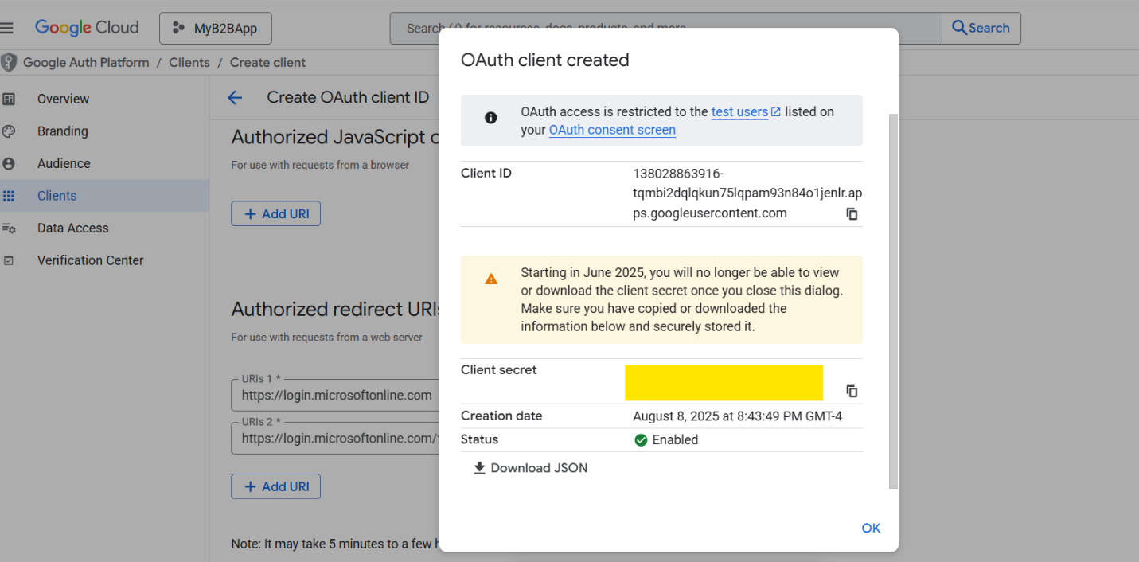
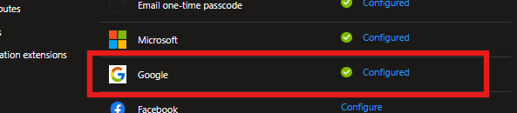
Created Conditional Access policy to enforce MFA, by user/location/device
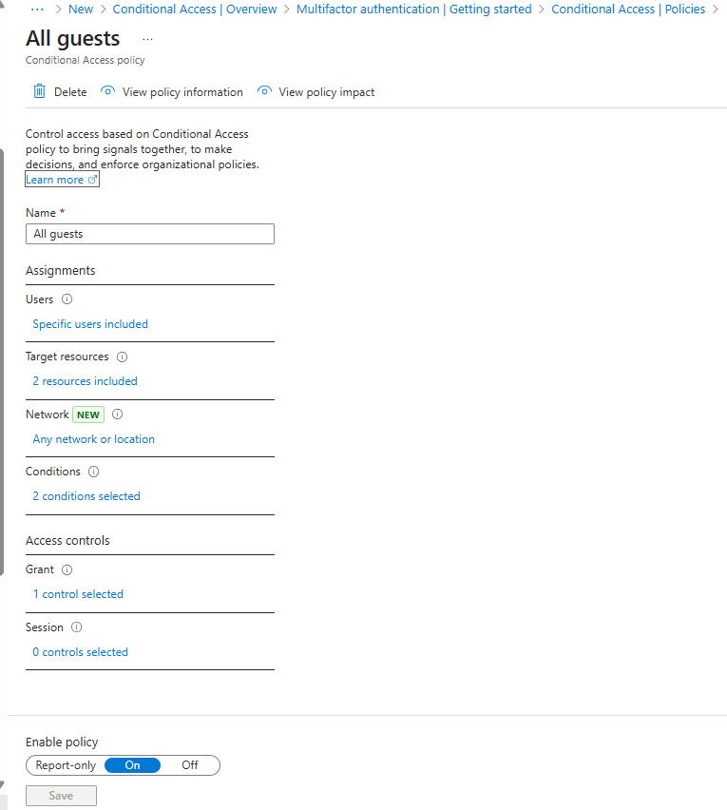
Enable multiple authN methods targeting All users (FIDO2, MSFT authenticator, etc.)
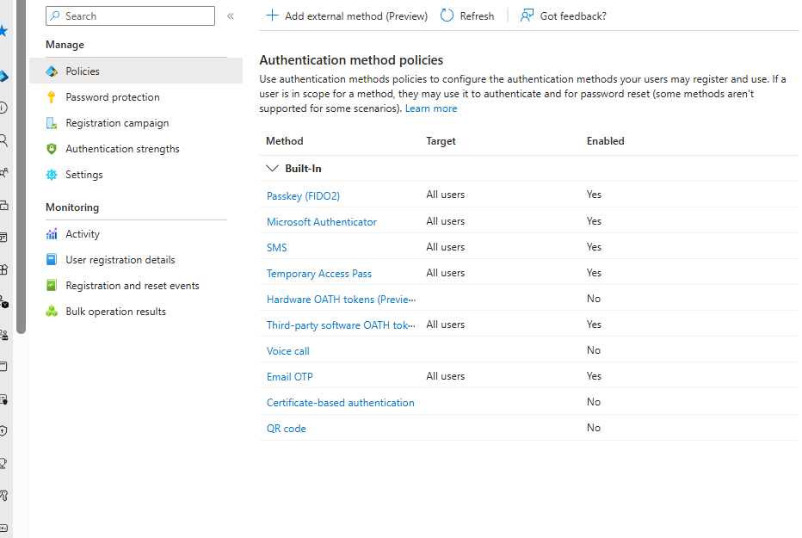
Enabled SSPR for a selected group
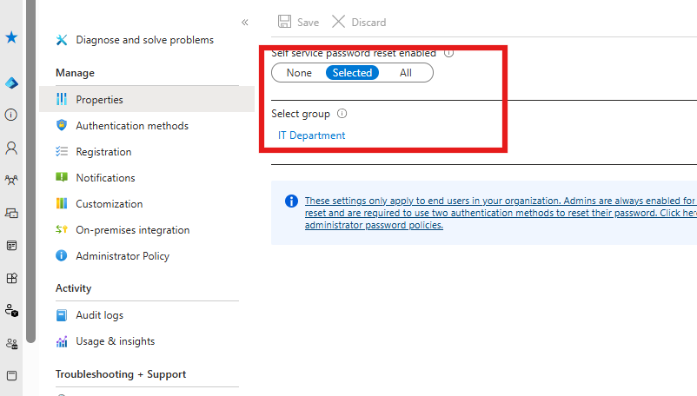
Tested using credentials from a user in the group
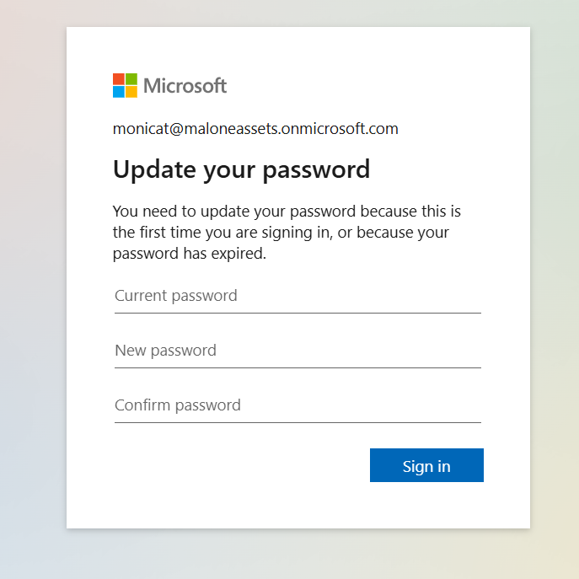
Ensured multiple auth methods were available
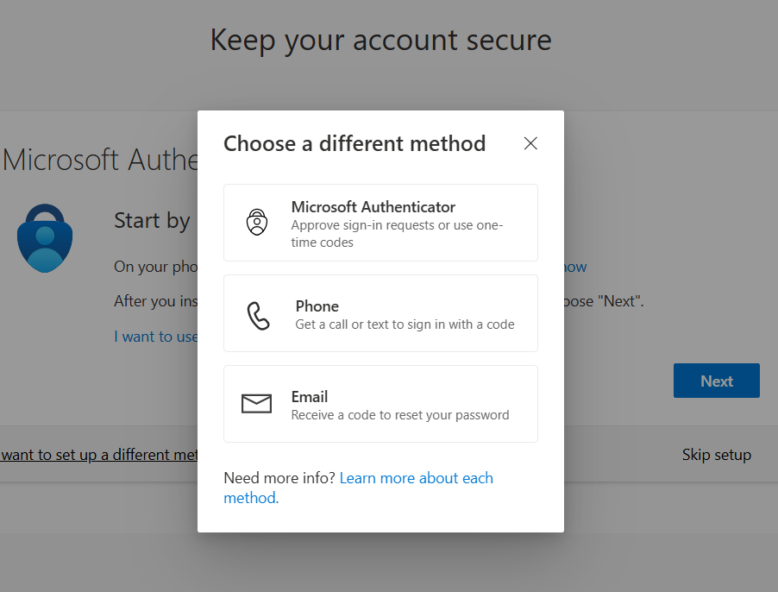
Tested Self Service Password Reset
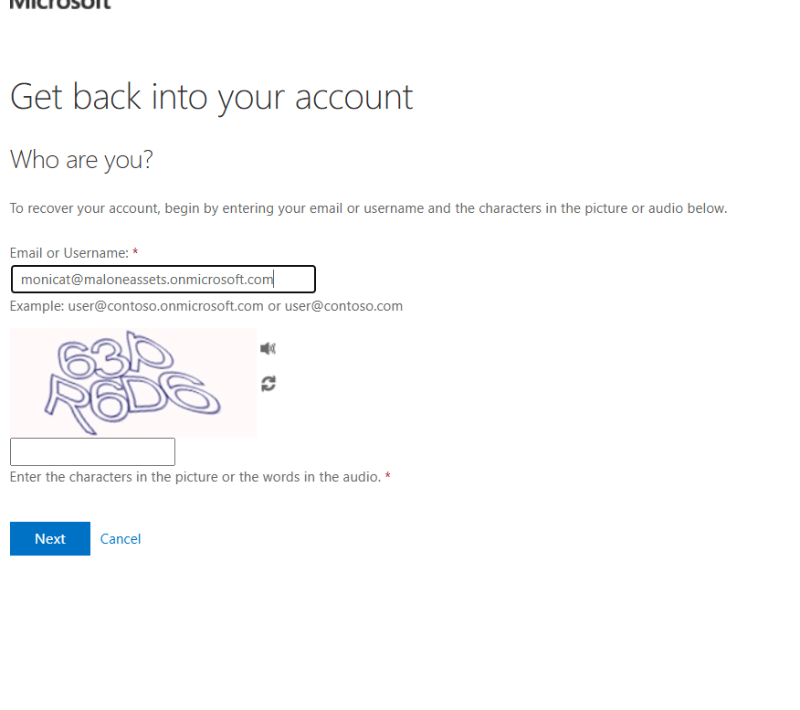
Met with a captcha

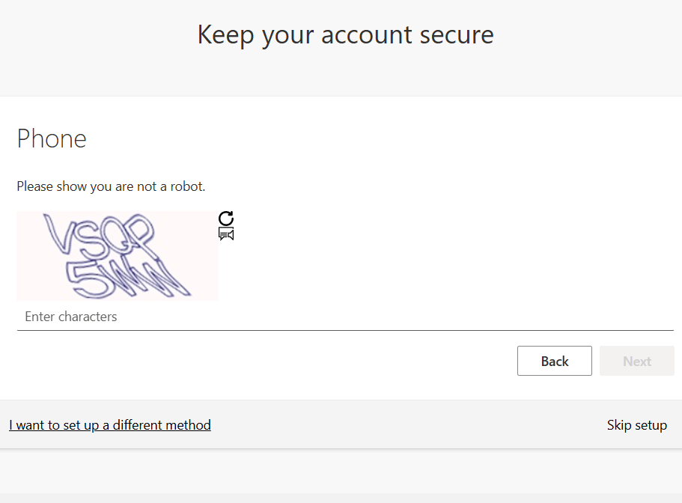
Password reset successful
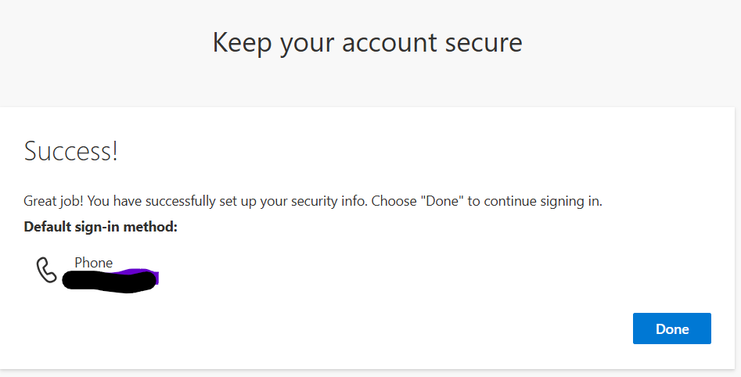
Managed smart lockouts by enforcing password protection
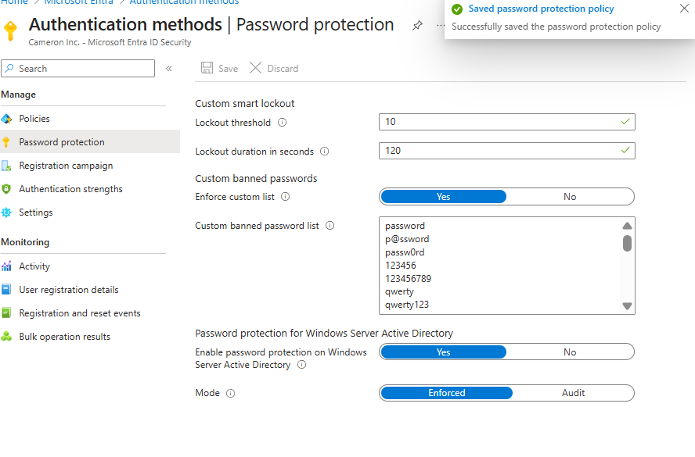
Reviewing CA logs to identify if any policies failed, and why
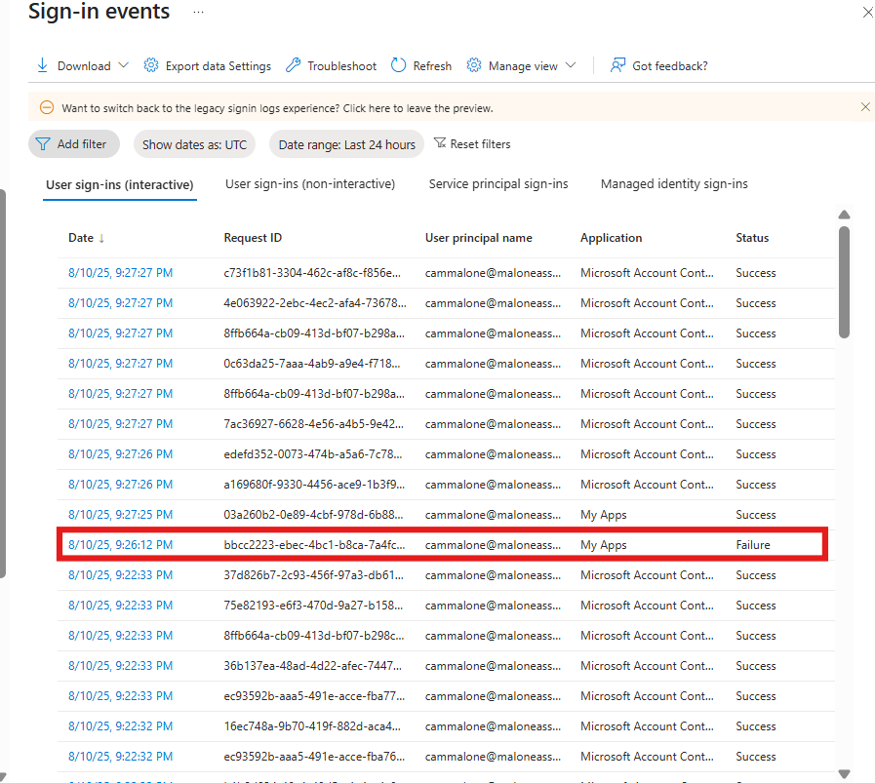
The policy was disabled, resulting in a failure
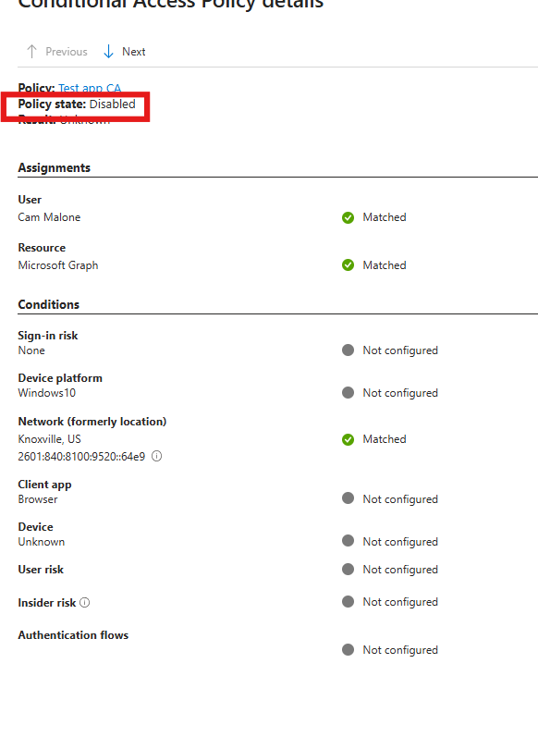
Implemented User risk & Sign-risk policies for all users, excluding emergency accounts
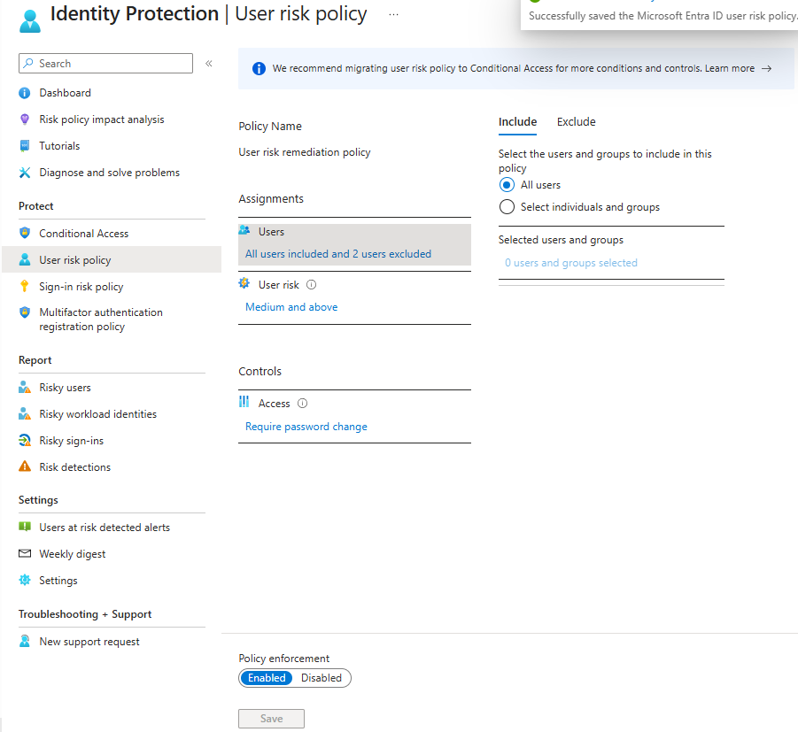
Configured Global Secure Access

